EXECUTIVE MEETING #5

May 13th 2016 5.03pm- 6.55pm Location: Macquarie University Campus

Present: Ryan Thalari (President), Anneliese Cooper (Secretary), Sarah McCabe (Treasurer), Alex Feolifoff, Mathew Duardo

Agenda Items:

1) Refund Policy
2) Financial Update
3) Australs Subsidies
4) Other Business

Meeting commenced: 5.03pm

AGENDA ITEM ONE: Refund Policy

Sarah: I have proposed the Refund Policy as per the email which I sent in April. It’s still exactly the same. I will now add to the policy that if someone opts into a tournament 3 days before the tournament then they won’t be penalised for not paying the rego cost before the required deadline

Alex: People should be able to figure out a payment plan with the Treasurer if they are unable to pay for the rego costs.

Sarah: Section 7 covers this. I think accountability between the Treasurer, President and Secretary is fine because it’s not too broad that it becomes complicated and still has enough accountability between those three people. If the personal payment plan wasn’t filled out then I think it’s safe to assume that they probably wouldn’t be able to go.

Alex: I think we should extend the deadline in Section 2 to 14 days rather than 7. 7 days is not long enough because by the time we then contact them and wait for them to get back to us and then decide that they can’t go, we still have to find a replacement. That then becomes way too short notice to be able to find someone else.

Ryan: I think we should also differentiate between Easters and other major tournaments for this 14 day period because Easters happens so early in the year.

Sarah: I’ll edit Section 1 so that it says 7 days for Easters and 14 for everything else

Mat: Where it says ‘discretion of the Executive’ we need to make more objective e.g. when we pass 2/3rds of the vote in favour of the motion

Sarah: Only 2 sections mention the discretion of the Executive and they are extreme circumstances and they are very subjective to circumstance. We can’t plan every for every situation

Ryan: Let’s make it a simple majority vote

Sarah: I’ll change Section 6 to a ‘simple majority’ vote

Alex: We should note that an emergency meeting can be held by the Executive via Skype

Sarah: I’ve emailed around the new policy

Ryan: The definition of ‘on-selling’ and ‘not belonging’ need to be changed.

Further changes were made to the policy document which are not substantial enough to record e.g. grammar or spelling errors or slight changes in wording

MOTION: Sarah moves motion to adopt the refund policy

Seconded by: Ryan

In favour: 5
Against: 0

MOTION PASSES UNANIMOUSLY

Final refund policy can be viewed here: http://muds.org.au/wpcontent/uploads/2012/10/MUDS-Refund-Policy1.pdf

AGENDA ITEM TWO – FINANCIAL UPDATE

Ryan: We have just enough money in our account to pay the second half of the Worlds payment. Easters 2016 conveners refunded Kelly’s unused spot.

At 5:58pm this happened….

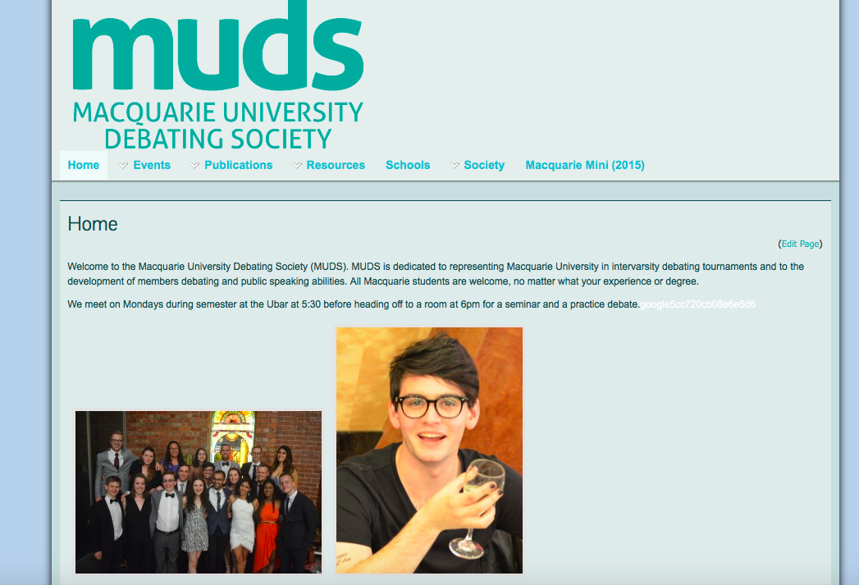

AGENDA ITEM THREE: AUSTRALS SUBSIDIES

Ryan: Full rego for Australs is $770. We have applied for $2000 of out-of-round funding from the SRC.

Alex: We should write down our proposed subsidy amounts so as not to be influenced by the first person’s suggestion as we negotiate subsidies right now.

Ryan: I don’t think we need to over complicate this motion

Sarah: I suggest $550 for rego

Ryan: I was thinking $430

Anneliese: Wait is this before or after SRC funding? If we don’t get the SRC funding and subsidise rego payments to that amount, won’t we be in debt?
Sarah: Yes. Right now we have $0 after we have paid for Worlds. We pay $2000 in rego then we gain $2500 from the rego payments. We then only have $500 in our account to pay for other expenses like Women’s round one payments.

IF SRC funding gets passed then we are able to subsidise more.

Anneliese: I think we need to play it safe and suggest a subsidised rego amount assuming that we won’t get SRC funding. Then once that is approved which will be way before Australs payments are due, we can lower rego costs and increase the subsidy. We can either ask the competitors to wait until we can approve the rego and then give them the guaranteed amount (e.g. say ‘don’t pay before x date’) or refund them the $70 difference once SRC funding has been confirmed.

Sarah: I think it’s important that we don’t get people’s hopes up about being to subsidise rego further so we need to word it clearly.

Externals need to circulate the refund policy and explain the signifance of it and how it applies to general members.

MOTION: Sarah proposes that Australs rego is $500 per person
Seconded by: Alex

MOTION PASSES UNANIMOUSLY

MOTION: Ryan proposes that we reduce rego costs for Australs to $430 if $2000 SRC funding is approved.

Seconded by: Sarah

MOTION PASSES UNANIMOUSLY

ACTION ITEM: Anneliese and Mat to figure out the fax spamming

ACTION ITEM: Update website

ACTION ITEM: People who have done presentations at Internals to send presentations to muds.internals@gmail.com if they feel comfortable doing so, so that we can build a database for future years and also help with Internals handover for 2017 Executive.

Meeting concluded: 6.55pm.

